**Arteriosclerosis**

**BY**

**MAGIRA KUTARJU**

**(ST/cst/BC/HND/24/014)**

**SEMINAR (STH 425)**

**A SEMINAR PRESENTED TO THE DEPARTMENT OF CHEMICAL SCIENCE TECHNOLOGY, FEDERAL POLYTECHNIC, MUBI, ADAMAWA STATE**

**JUNE, 2025**

**DECLARATION**

I declare that this seminar entitled **Arteriosclerosis** was carried out by me **Magira Kutarju ST/cst/BC/HND/23/014** of the Department of Chemical Science Technology, Federal Polytechnic, Mubi.All literature and information, sourced are duly acknowledged.

   
Magira Kutarju …………………

(ST/CST/BC/HND/23/014) Sign/Date

**CERTIFICATION**

This is to certify that this seminar paper on **Arteriosclerosis** was written by **Magira Kutarju** with registration number **ST/cst/BC/HND/23/014** and presented to the department of Chemical Science and Technology, Federal Polytechnic, Mubi.

Mr. Abdulrazaq Bello …………………

(Project Supervisor) Sign/Date

Mr. Sudi P. D. ……………………

(Head of Department) Sign/Date

**Introduction**

Arteriosclerosis and atherosclerosis are sometimes used to mean the same thing. But there's a difference between the two terms. **Arteriosclerosis** happens when the blood vessels that carry oxygen and nutrients from the heart to the rest of the body become thick and stiff. These blood vessels are called arteries. Healthy arteries are flexible and elastic. But over time, the walls in the arteries can harden, a condition commonly called hardening of the arteries. Arteriosclerosis is a general term describing the loss of elasticity and thickening of arterial walls, which impedes blood flow and increases cardiovascular risk (Libby, 2021). Among its types, atherosclerosis is the most clinically significant due to its association with coronary artery disease (CAD), stroke, and peripheral vascular diseases. Despite global advancements in healthcare, arteriosclerosis remains one of the top contributors to non-communicable disease deaths, accounting for over 17 million deaths annually (WHO, 2023). The need for early detection, effective intervention, and public awareness is greater than ever.

Cardiovascular diseases (CVDs) have remained the leading cause of death globally, with arteriosclerosis standing out as one of the principals underlying pathological mechanisms responsible for many cardiovascular events. The term *arteriosclerosis* is derived from Greek roots — *arteria* (artery) and *sklerosis* (hardening), and broadly refers to the progressive thickening, stiffening, and loss of elasticity of the arterial walls (Libby, 2021). It is a chronic degenerative condition that significantly impairs vascular function by reducing arterial compliance and lumen diameter, thereby increasing vascular resistance and reducing perfusion to critical organs such as the heart, brain, and kidneys.

The umbrella term “arteriosclerosis” encompasses several distinct but related vascular pathologies, namely atherosclerosis, arteriolosclerosis, and Monckeberg’s medial sclerosis, each of which affects different types of blood vessels and exhibits unique histopathological features (Cai *et al.,* 2022). Among these, atherosclerosis characterized by the accumulation of lipid-laden plaques within the intima of medium- and large-sized arteries is the most prevalent and clinically significant form, often implicated in conditions such as myocardial infarction, stroke, and peripheral artery disease (Newman *et al.,* 2022).

The genesis and progression of arteriosclerosis are multifactorial, involving a complex interplay of genetic predisposition, metabolic disturbances, hemodynamic stress, and lifestyle-related factors such as smoking, poor diet, physical inactivity, and chronic inflammation. Notably, non-communicable risk factors like hypertension, hyperlipidemia, and type 2 diabetes mellitus are strongly associated with the development and acceleration of arteriosclerotic changes (Yeboah *et al.,* 2023).

From a public health perspective, arteriosclerosis poses an enormous challenge, particularly in low- and middle-income countries, where the burden of cardiovascular diseases is rising due to urbanization, increased life expectancy, and adoption of Westernized lifestyles. According to the World Health Organization (2023), cardiovascular diseases — largely driven by arteriosclerotic changes account for nearly 17.9 million deaths annually, representing about 32% of all global deaths. Recent advances in diagnostic imaging, biomarker discovery, and pharmacologic interventions have significantly improved our ability to detect and manage arteriosclerosis. However, the asymptomatic nature of early-stage disease and inadequate access to healthcare services in some regions remain major barriers to early intervention.

Given the multifaceted nature of this disease, a comprehensive understanding of its pathophysiology, risk factors, clinical manifestations, and preventive strategies is vital for both healthcare practitioners and policymakers. This seminar article aims to provide an in-depth review of the current scientific understanding of arteriosclerosis, highlighting recent developments in diagnosis, treatment, and prevention strategies to address the growing global burden.

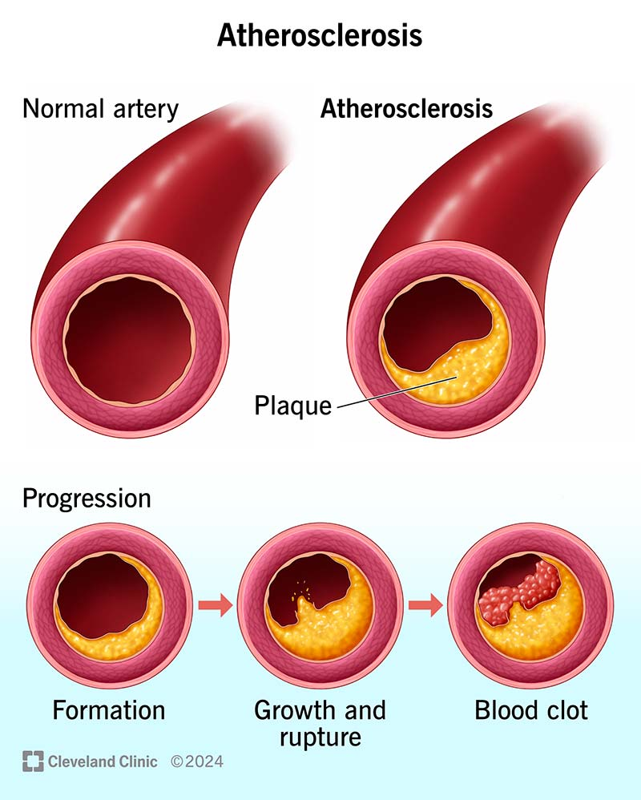

Figure 1: Arteriosclerosis

**Literature Review**

The scientific understanding of arteriosclerosis has evolved significantly over the past few decades, thanks to interdisciplinary research in vascular biology, immunology, pathology, and clinical medicine. This section explores the key literature concerning the types, pathophysiology, risk factors, and diagnostic tools of arteriosclerosis, drawing upon recent peer-reviewed studies and authoritative sources.

**Pathophysiology of Arteriosclerosis**

The condition begins with endothelial injury, which could be triggered by hypertension, hyperlipidemia, smoking, or diabetes (Bentzon *et al.,* 2021). Damaged endothelial cells become permeable to lipids, particularly low-density lipoprotein (LDL) cholesterol. These lipids oxidize, inciting an inflammatory response. Macrophages ingest oxidized LDL, transforming into foam cells and forming fatty streaks the earliest sign of atherosclerotic plaque (Libby, 2021). Over time, these plaques may calcify, rupture, or occlude the vessel, resulting in ischemic events.

Oxidized LDL (oxLDL) acts as a potent pro-inflammatory stimulus, attracting monocytes from the bloodstream. These monocytes differentiate into macrophages, engulf oxLDL, and become foam cells forming the fatty streak, which is the earliest visible lesion of atherosclerosis (Libby, 2021). As inflammation progresses, smooth muscle cells migrate from the media to the intima, proliferate, and produce extracellular matrix components, contributing to plaque growth and fibrosis.

Advanced plaques may undergo calcification, ulceration, or rupture, triggering the formation of a thrombus (blood clot) which can completely occlude the vessel and cause acute cardiovascular events such as myocardial infarction or stroke (Toth *et al.,* 2023).

**Types of Arteriosclerosis**

Arteriosclerosis is not a single disease but a group of disorders involving arterial wall thickening and loss of elasticity. It is generally classified into three major subtypes:

1. **Atherosclerosis**: The most studied and clinically significant type, atherosclerosis involves the deposition of lipids, inflammatory cells, and fibrous elements in the intimal layer of large and medium-sized arteries. This leads to the formation of plaques that narrow the lumen and impair blood flow. Atherosclerosis is the underlying cause of most ischemic heart diseases and strokes (Libby, 2021).
2. **Arteriolosclerosis**: This form affects the small arteries and arterioles, particularly in patients with chronic hypertension and diabetes. It is histologically classified into hyaline arteriolosclerosis (associated with protein leakage and smooth muscle degeneration) and hyperplastic arteriolosclerosis (characterized by concentric smooth muscle proliferation), both of which contribute to end-organ damage, especially in the kidneys (Cai *et al.,* 2022).
3. **Monckeberg’s Medial Calcific Sclerosis**: Unlike atherosclerosis, this subtype involves calcification of the tunica media without significantly obstructing the arterial lumen. It is typically found in older adults and individuals with diabetes and chronic kidney disease, and though it rarely causes direct ischemia, it increases vascular stiffness and pulse pressure (Cai *et al.,* 2022; Yeboah *et al.,* 2023).

**Risk Factors**

A wide array of **non-modifiable and modifiable risk factors** have been linked to the development and progression of arteriosclerosis. These include:

1. **Non-modifiable Risk Factors**:
   1. **Age**: Incidence increases with age due to cumulative vascular damage.
   2. **Gender**: Men are at higher risk until women reach menopause.
   3. **Genetics**: Family history of cardiovascular disease is a strong predictor (Yeboah *et al.,* 2023).
2. **Modifiable Risk Factors**:
   1. **Hyperlipidemia**: Elevated LDL-C and low HDL-C levels are primary contributors to plaque formation.
   2. **Hypertension**: Damages the endothelial lining and promotes plaque instability.
   3. **Smoking**: Induces oxidative stress, inflammation, and endothelial dysfunction.
   4. **Diabetes Mellitus**: Hyperglycemia accelerates atherosclerosis through glycation end-products.
   5. **Obesity and Sedentary Lifestyle**: Promote metabolic syndrome and systemic inflammation.
   6. **Diet**: High intake of saturated fats, trans fats, and refined sugars is associated with increased cardiovascular risk (Sabatine *et al.,* 2023).

**Symptoms**

Mild atherosclerosis usually doesn't cause symptoms.

Atherosclerosis symptoms usually don't happen until an artery is so narrowed or clogged that it can't send enough blood to organs and tissues. Sometimes a blood clot completely blocks blood flow. The clot may break apart. If this happens, it may cause a heart attack or stroke.

Symptoms of moderate to severe atherosclerosis depend on which arteries are affected. For example, if you have atherosclerosis:

1. **In your heart arteries,** you may have chest pain or pressure, called angina.
2. **In the arteries leading to your brain,** you may have sudden numbness or weakness in your arms or legs, trouble speaking, slurred speech, sudden or temporary loss of vision in one eye, or drooping muscles in your face. These are symptoms of a transient ischemic attack (TIA). Untreated, a TIA can lead to a stroke.
3. **In the arteries in your arms and legs,** you may have leg pain when walking, called claudication. This is a symptom of peripheral artery disease (PAD). You also might have lower blood pressure in the affected arm or leg.
4. **In the arteries leading to your kidneys,** you may get high blood pressure or kidney failure.

#### ****Diagnosis and Clinical Manifestations****

Arteriosclerosis is often referred to as a “silent” disease due to its asymptomatic nature during the early stages. The condition progresses gradually, and clinical symptoms typically do not appear until significant arterial narrowing has occurred, leading to reduced blood flow and tissue ischemia. When symptoms do manifest, they depend on the specific arteries affected for instance, chest pain in coronary artery disease or leg pain in peripheral artery disease. Diagnostic evaluation of arteriosclerosis relies on a combination of biochemical, imaging, and biomarker assessments. Blood lipid panels are essential for measuring cholesterol and triglyceride levels, which are key indicators of dyslipidemia a major risk factor for atherosclerosis. Advanced imaging techniques such as computed tomography (CT) angiography, Doppler ultrasound, and coronary artery calcium (CAC) scoring provide visual and quantitative data on the extent of arterial blockages and calcifications. In addition, biomarkers such as high-sensitivity C-reactive protein (hs-CRP) are increasingly used to detect underlying inflammation and assess cardiovascular risk, particularly in individuals without overt symptoms (Toth *et al.,* 2023).

Furthermore, recent advances in **non-invasive vascular testing** have expanded diagnostic options. Tools such as **Ankle-Brachial Index (ABI)** testing are useful for detecting peripheral artery disease in at-risk individuals, while **pulse wave velocity (PWV)** measurement is emerging as a strong indicator of arterial stiffness and overall cardiovascular risk. Genetic screening is also being integrated into clinical practice to identify hereditary predispositions to arteriosclerosis, particularly in younger individuals with early-onset disease. These innovations underscore the importance of early screening, especially among high-risk populations, and support a shift toward preventive rather than reactive cardiovascular care.

#### ****Complications****

Arteriosclerosis is a critical precursor to several potentially fatal conditions affecting major organ systems. One of the most common and severe complications is **coronary artery disease (CAD)**, where atherosclerotic plaque accumulation within the coronary arteries impairs oxygen delivery to the heart muscle. This can result in angina pectoris (chest pain), myocardial infarction (heart attack), and even sudden cardiac death. Another significant complication is **cerebrovascular disease,** particularly when atherosclerosis affects the carotid arteries supplying blood to the brain. This may lead to transient ischemic attacks (TIAs) or full-blown strokes, both of which carry high risks of disability and death. In addition, **peripheral artery disease (PAD)** occurs when the arteries supplying the limbs especially the legs are affected. PAD is characterized by symptoms such as intermittent claudication (pain during walking) and, in advanced cases, may lead to critical limb ischemia, ulceration, and gangrene, which can necessitate amputation (Newman *et al.,* 2022).

#### ****Management and Prevention****

Effective management and prevention of arteriosclerosis involve a multi-pronged approach, with **lifestyle modification** serving as the foundational strategy. A heart-healthy diet such as the **Mediterranean diet** that is rich in fruits, vegetables, whole grains, lean proteins, and unsaturated fats has been shown to significantly reduce cardiovascular risk. Physical activity is equally important; engaging in at least 150 minutes of moderate-intensity aerobic exercise per week is widely recommended to enhance vascular function, improve lipid profiles, and maintain a healthy weight. **Pharmacotherapy** plays a crucial role in managing patients who are at high risk or who already show signs of arteriosclerosis. Statins are the primary agents used to lower LDL cholesterol levels and stabilize existing plaques. Other medications include antihypertensives to manage blood pressure and antiplatelet agents to prevent thrombus formation. In more severe cases where significant arterial occlusion compromises blood flow, **surgical interventions** such as percutaneous coronary intervention (angioplasty), stent placement, or coronary artery bypass grafting (CABG) may be necessary to restore adequate perfusion (Sabatine *et al.,* 2023). Early detection, continuous monitoring, and patient adherence to therapeutic regimens are essential for effective long-term management.

**Prevention**

The same healthy lifestyle changes recommended to treat atherosclerosis also help prevent it. These lifestyle changes can help keep the arteries healthy:

1. Do not smoke or use tobacco.
2. Eat nutritious foods.
3. Get regular exercise and keep an active lifestyle.
4. Keep a healthy weight.
5. Control blood pressure, blood sugar and cholesterol.

**Conclusion**

Arteriosclerosis remains a significant global health concern due to its pervasive role in the development of cardiovascular diseases, which are among the leading causes of mortality and morbidity worldwide. As a progressive condition marked by the thickening and stiffening of arterial walls, arteriosclerosis disrupts normal vascular function, leading to life-threatening complications such as myocardial infarction, stroke, and peripheral artery disease. Despite being largely preventable, the disease continues to claim millions of lives annually, especially in low- and middle-income countries where access to healthcare and public health education may be limited. This seminar has explored the pathophysiology, risk factors, diagnostic approaches, complications, and management strategies associated with arteriosclerosis.

**Recommendations**

Based on the findings and discussions in this seminar, the following recommendations are proposed:

1. Awareness campaigns should be launched to educate the public about the causes, risk factors, and prevention of arteriosclerosis. S
2. Healthcare providers should implement routine cardiovascular risk assessments for individuals aged 40 and above, as well as younger individuals with a family history of heart disease.
3. Governments and healthcare institutions should support community-based programs that encourage physical activity, smoking cessation, healthy eating, and weight management.
4. Statins, antihypertensives, and antiplatelet agents should be made more accessible and affordable, particularly in low-income settings.
5. Government policies should regulate the marketing of high-sodium, trans-fat, and sugary products.

**References**

Bentzon, J. F., Otsuka, F., Virmani, R., & Falk, E. (2021). Mechanisms of plaque formation and rupture. *Nature Reviews Cardiology, 18*(7), 394–406.

Cai, Y., Zhong, H., & Lin, X. (2022). Medial artery calcification and its clinical significance. *Journal of Vascular Research, 59*(3), 120–129. https://doi.org/10.1159/000521214

Libby, P. (2021). The changing landscape of atherosclerosis. *Nature, 592*(7855), 524–533.

Newman, J. D., Vani, A. K., & Karmali, K. N. (2022). Cardiovascular disease prevention in the 21st century. *Journal of the American College of Cardiology, 79*(9), 883–898.

Sabatine, M. S., Giugliano, R. P., Keech, A. C., Honarpour, N., & Wiviott, S. D. (2023). Advances in lipid-lowering therapy: 2023 update. *The Lancet, 401*(10377), 1544–1555.

Toth, P. P., Nikolic, D., Hovingh, G. K., & Cuchel, M. (2023). Inflammation and cardiovascular risk: biomarkers and strategies. *Current Atherosclerosis Reports, 25*(2), 134–145. https://doi.org/10.1007/s11883-023-00975-2

World Health Organization (WHO). (2023). *Cardiovascular diseases (CVDs)*. <https://www.who.int/news-room/fact-sheets/detail/cardiovascular-diseases-(cvds)>

Yeboah, J., McClelland, R. L., Polonsky, T. S., Burke, G. L., & Greenland, P. (2023). Risk factors and prevalence of subclinical atherosclerosis. *JAMA Cardiology, 8*(1), 56–64.